Title: Imber, Book One of the Thanatos Trilogy
Author: Tyffany Hackett
Release Date: 6/12/18
Genre: Sword and Sorcery Fantasy
Category: Young Adult
ISBN: 978-1-7320307-2-5
EBook ISBN: 978-1-7320307-0-1
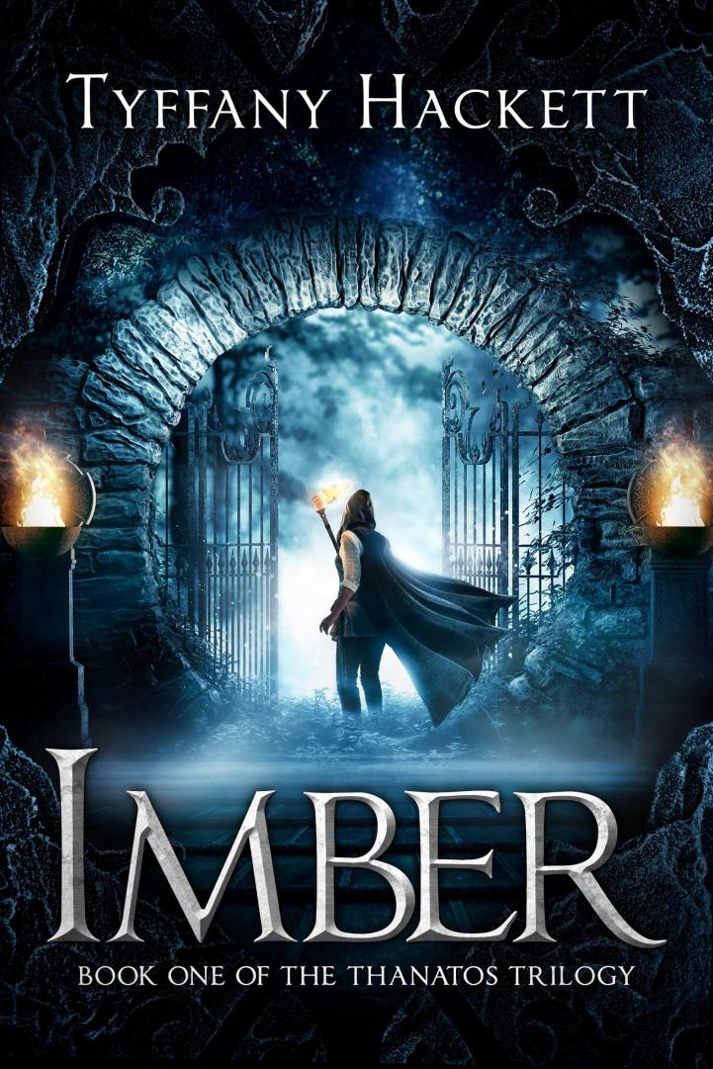

Synopsis:

The locks are failing.
The keys are calling.
The Titans are waking.
Crowned before her time, nineteen-year-old Natylia is thrust into an unpleasant reality—her people don’t want her, her family doesn’t need her and, despite her best efforts, she can’t seem to shake an incorrigible suitor. But when rumors begin to swirl throughout her kingdom the young queen shifts her focus and realizes that the world she loves could be destroyed in an instant.

An ancient enemy, long thought gone, is trying to return.

Forgotten legends have resurfaced, stories that tell of three scepters: the keys to unleashing these foul beings. Across Araenna the hunt rages for this trio of formidable power—to command the keys is to hold the power of mortal gods.

Aided by her snarky elven bodyguard, an unassuming blacksmith, and a clever nature witch, Natylia races to correct the mistakes of the past… before they can destroy her people’s future.

Buy links:

Amazon US: https://www.amazon.com/dp/B07CMGSDRD
Amazon UK: https://www.amazon.co.uk/dp/B07CMGSDRD
Amazon CA: https://www.amazon.ca/dp/B07CMGSDRD
Amazon AU: https://www.amazon.com.au/dp/B07CMGSDRD
B&N: -to be updated-
The Book Depository: -to be updated-

Goodreads: https://www.goodreads.com/book/show/39943836-imber

Author Links
Website: http://www.tyffanyhackett.com
Instagram: http://www.instagram.com/tyffany.h
Twitter: http://www.twitter.com/Tyffany_H
Facebook: http://www.facebook.com/tyffanyhackettauthor
Tumblr: https://tyffanyh.tumblr.com/
Goodreads: https://www.goodreads.com/TyffanyH

Author Bio:

Tyffany is an aspiring author from New York who spends her days picking up after her rambunctious two year old. At night, however, she writes — sinking deep into the fantasy world that she is about to release into the world.
​
Other than writing, Tyffany likes to play video games, read, and paint. Once a month she makes time to sit down and enjoy the shenanigans of a good round of D&D. Not much for TV, she still marathons the Lord of the Rings trilogy, Xena, and Parks & Rec more than she’d care to admit.

